Map of th 4th Story at the University of Denver

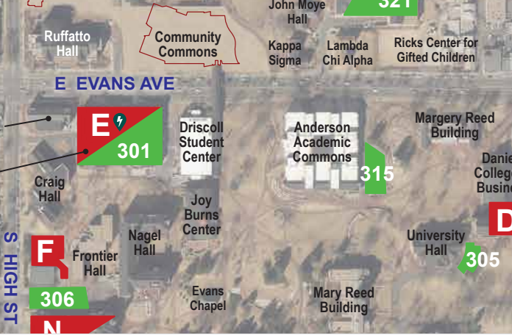
Suggested Driving and parking directions: From the intersection of University Boulevard and Evans Avenue, drive west on Evans. Drive underneath the building that bridges over the street and then take a left (South) onto High Steet, turn quickly left (East) into the driveway leading to the guest parking lot (labeled 301 in this map). Near the NW corner of the garage is a crosswalk across Evans Avenue. Going north, walk along Race Street, then enter the Community Commons at the entrance marked with a star. Continue east through the building and then turn right to access the elevator. Take the elevator to the 4th floor and you’ll be there!

